NAME: VIGNESHWAR.D
REG.NO: 192524415
COURSE: CSA1515-Cloud Computing

EXPERIMENT 12
LIBRARY BOOK MANAGEMENT SYSTEM USING (SAAS)

AIM:
To create a simple cloud-based Library Book Management system Application Using Zoho Creator , a Saas Platform.

IMAGES:
Dashboard:
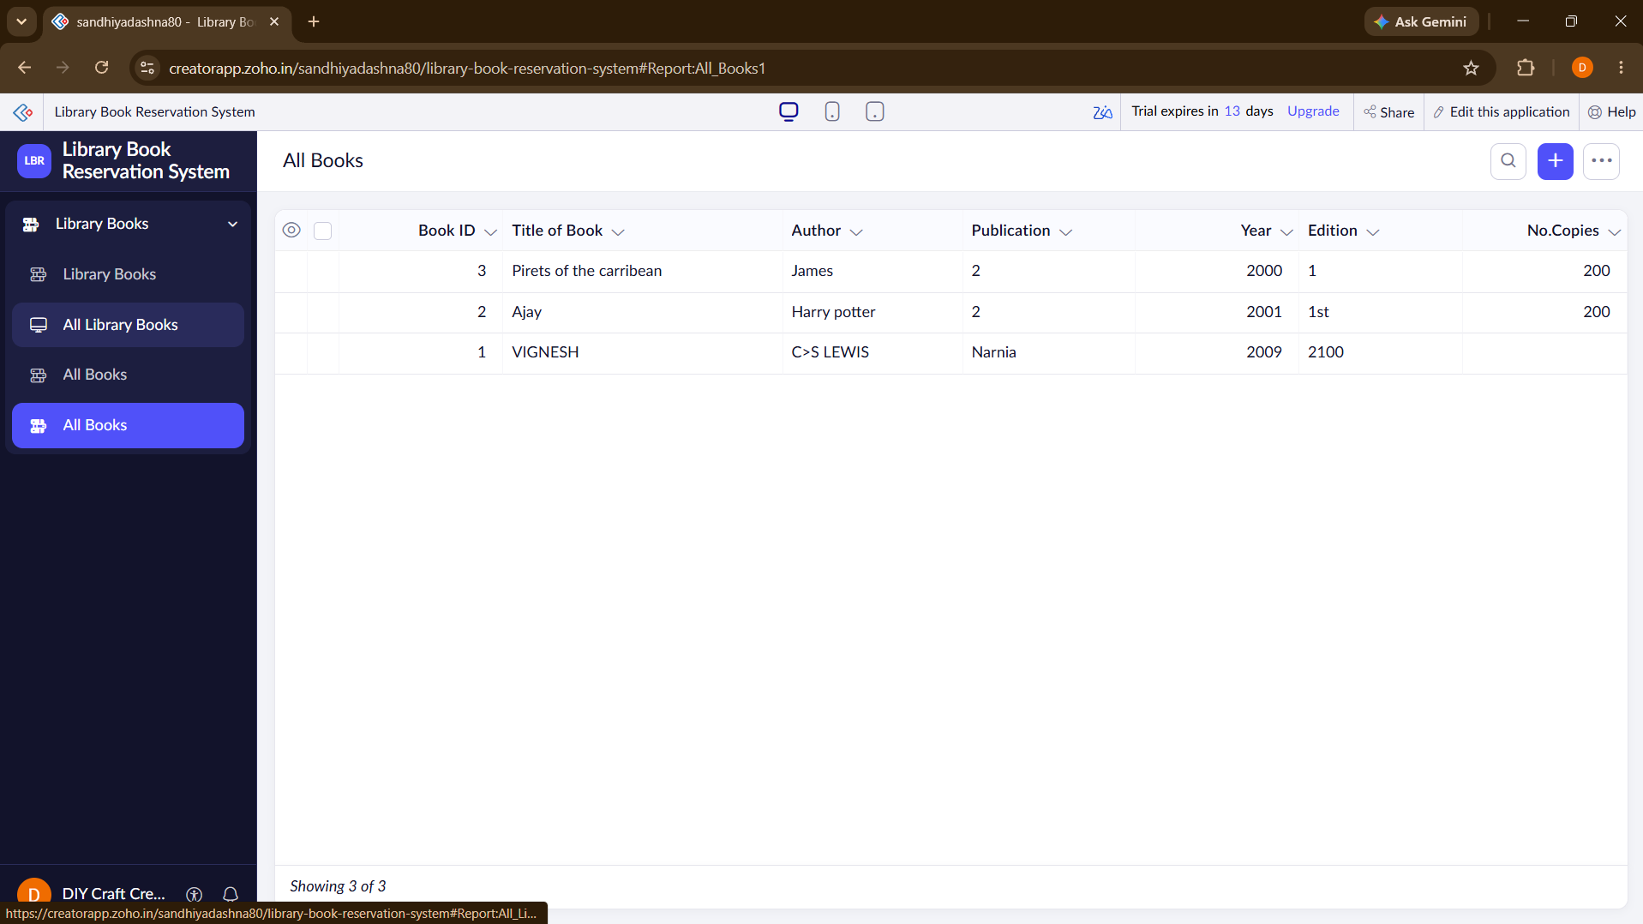

FORM:
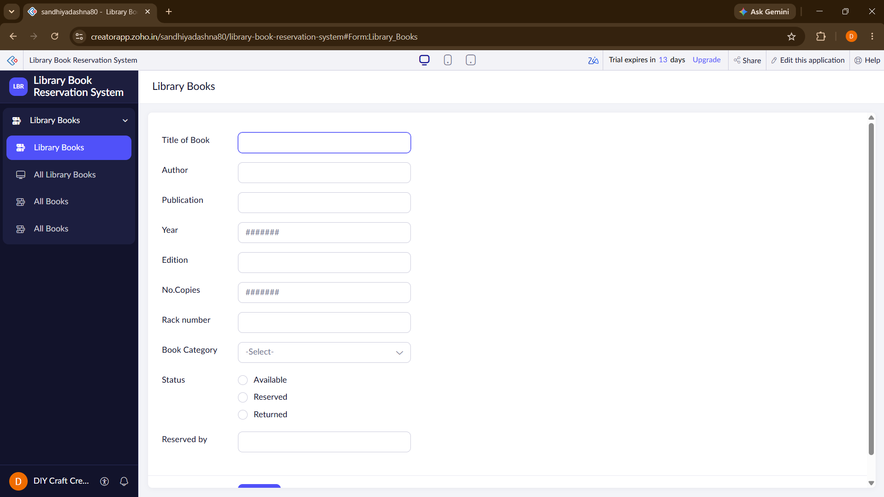

REPORT:

